Containers

For this assignment I will be installing Docker and Kubernetes on both servers. Docker is a tool which allows the deployment of applications inside Linux containers. Kubernetes is similar in how it is also a tool for managing containerized workloads. After installing both Docker and Kubernetes, I will also be installing Minikube.

Docker on CentOS

The first thing we need to do is make sure our list of packages from our repositories and PPA’s are up to date. To perform this update, run the following command.

sudo yum -y update

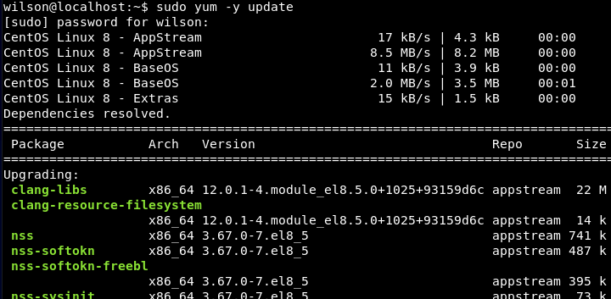

Next, we also need to make sure our yum utilities are install. Run the following command to install the yum utils.

sudo yum install -y yum-utils

Moving on, we now need to add the Docker repository to our APT sources. Performing this command will also update our package database with the latest Docker packages. To add the repository, run the following command.

sudo yum-config-manager \

--add-repo \

https://download.docker.com/linux/centos/docker-ce.repo

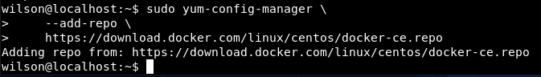

Now that we have the repositories set up, we can install the latest Docker engine. Use the following command to install the Docker engine. After installing the Docker engine, run the second command to start Docker.

sudo yum install docker-ce docker-ce-cli containerd.io

sudo systemctl start docker



Now that docker is installed, we can verify if it is working correctly by using the hello-world image. The hello world image simply runs in a container and prints a message, then exits. This can verify if Docker is working correctly.

sudo docker run hello-world

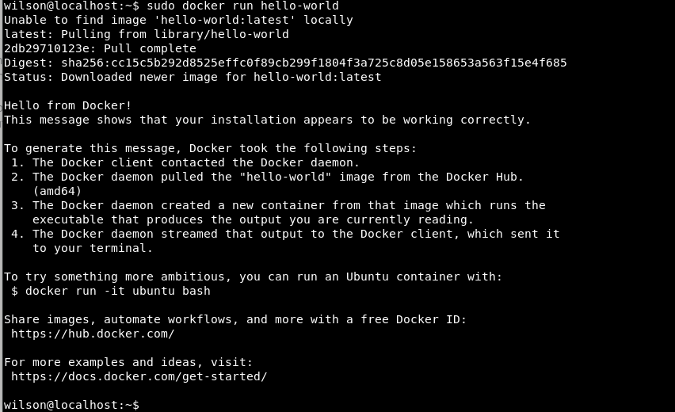After running the hello-world docker image, you should see this, indicating that Docker is working correctly.

Kubernetes on CentOS

Since Docker is up and running, I can now install Kubernetes. First we need to add a signing key and download the Kubernetes packages. Use the following command.

cat <<EOF > /etc/yum.repos.d/kubernetes.repo

[kubernetes]

name=Kubernetes

baseurl=https://packages.cloud.google.com/yum/repos/kubernetes-el7-x86_64

enabled=1

gpgcheck=1

repo_gpgcheck=1

gpgkey=https://packages.cloud.google.com/yum/doc/yum-key.gpg https://packages.cloud.google.com/yum/doc/rpm-package-key.gpg

EOF

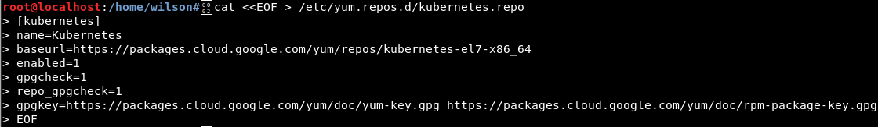

Now we can install the Kubernetes packages kubeadm, kubelet, and kubect1. Kubelet is the command to bootstrap the cluster, kublet can start pods and containers, and kubect1 is a command line utility to communicate with your cluster. Install these packages with the following commands. Then emable and start kubelet.

sudo yum install -y kubelet kubeadm kubectl

systemctl enable kubelet

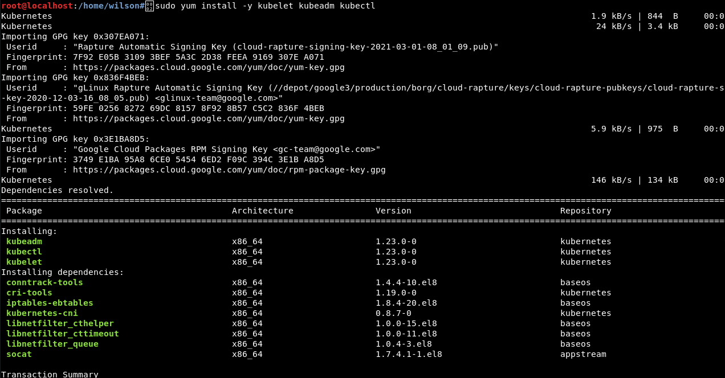systemctl start kubelet





Now Kubernetes should be successfully installed on both the master node and worker node.

Minikube

Minikube allows us to run Kubernetes in a single node cluster within a virtual machine. This will let us demo Kubernetes on a small scale without a full configuration.

The first thing we should do is install wget, this tool will help us download the latest release of minikube

sudo yum -y install wget

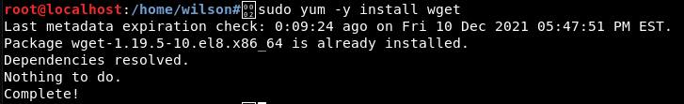

Now we use wget to install minikube with the following command.

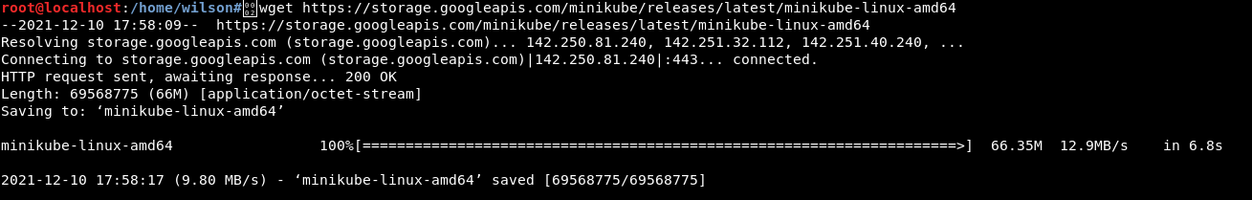wget <https://storage.googleapis.com/minikube/releases/latest/minikube-linux-amd64>

Now lets make the minikube binary executable and movie it to usr/local/bin using the following commands.

chmod +x minikube-linux-amd64

sudo mv minikube-linux-amd64 /usr/local/bin/minikube



Confirm that minikube is successfully installed using the following command.

minikube version



Lets check the status of our minikube with the following command. We can now see that minikube is installed but not started yet. Use the second command provided to start minikube using the Docker driver.

minikube status

minikube start --driver=docker

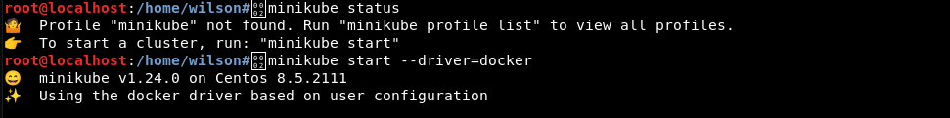

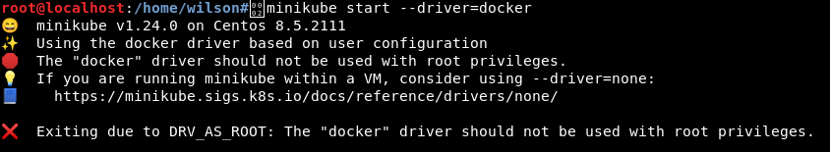Note: You may get an error with permission denied when running it with docker. It will look like this. If this happens, run the following command. Replace $USER with your user name in Linux. This will give your user permissions to user Docker with minikube

sudo usermod -aG docker $USER && newgrp docker

Now to open the dashboard, use the following command.

minikube dashboard

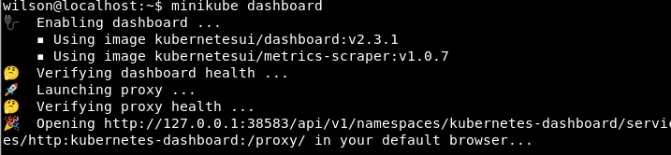

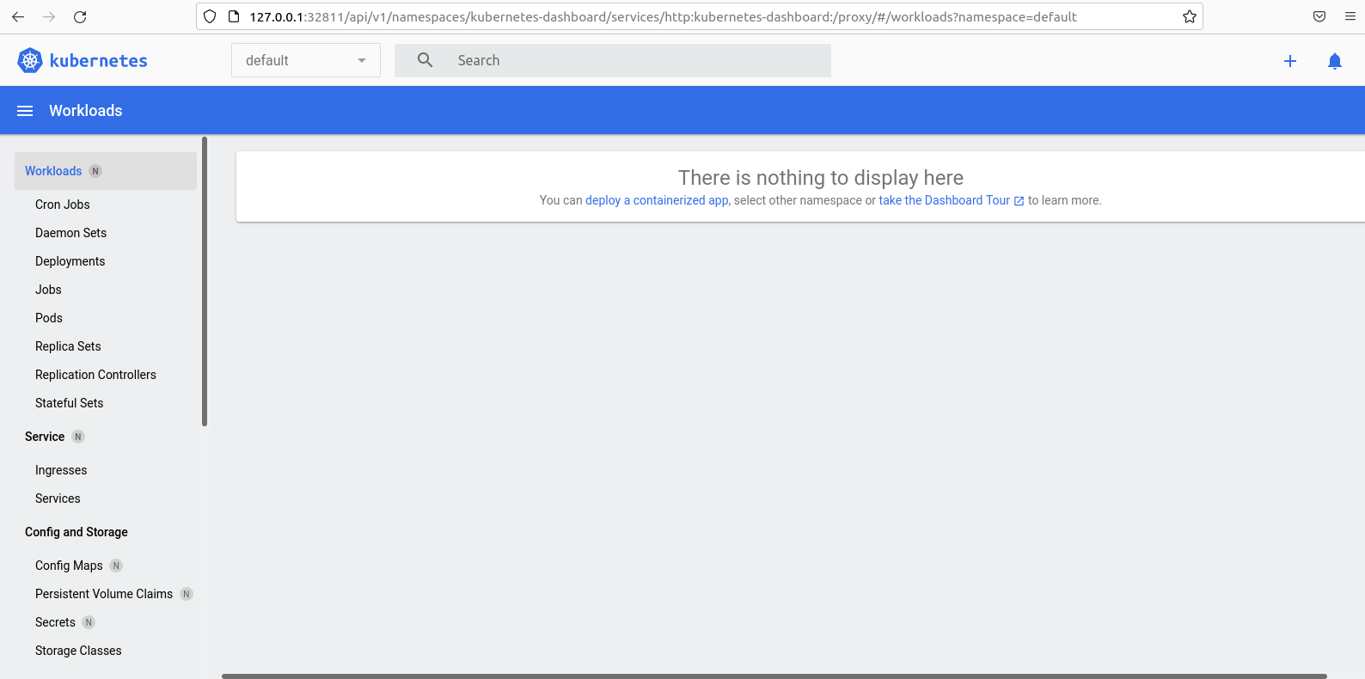In your default browser, you should now see a the Kubernetes dashboard window

Now that we know the dashboard is working, lets create a deployment to manage a pod. The pod runs a container based upon our docker image. Running the following kubectl command to create the deployment. Then use the second command to view the deployment and verify it is working.

kubectl create deployment hello-node --image=k8s.gcr.io/echoserver:1.4



kubectl get deployments



Now lets create a service to open our hello-node to outside the Kubernetes network. We can do this by exposing the pod as a Kubernetes service. Use the following command to expose the pod on port 8080.

kubectl expose deployment hello-node --type=LoadBalancer --port=8080



Now lets check our services with the following command. You should now see the hello-node within the services.

kubectl get services

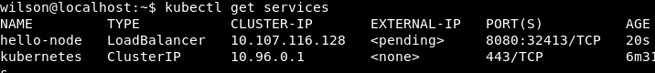

Now we can run the hello node service. Perform this with the following command. You should now see a window pop up with information from the hello-node.

minikube service hello-node

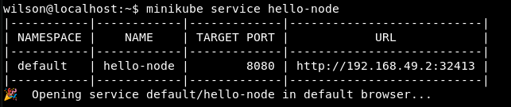

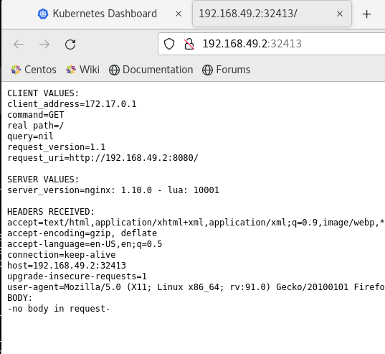

Since we have successfully got the service running, lets clean up our cluster and finish by removing the resources. Run the following commands to delete the kubectl service and our deployment of hello-node.

kubectl delete service hello-node

kubectl delete deployment hello-node

Finally stop and delete minikube with the following commands.

minikube stop

minikube delete

